EXP 6 – VERSION 2
FEEDFORWARD AND CONVOLUTIONAL NEURAL NETWORKS

AIM
To implement Feedforward Neural Network (FNN) and Convolutional Neural Network (CNN) models using TensorFlow and Keras for image classification using the Fashion-MNIST and MNIST datasets.

PROCEDURE
- Import the required Python libraries.
- Load the Fashion-MNIST dataset for the FNN.
- Normalize and flatten the input images.
- Build and compile an FNN with different dense layers.
- Train and evaluate the FNN model.
- Load the MNIST dataset for the CNN.
- Normalize and reshape the images.
- Build and compile a CNN with convolution, pooling and dropout layers.
- Train and evaluate the CNN model.
- Display sample predictions and accuracy.

CODE
import numpy as np
import matplotlib.pyplot as plt import tensorflow as tf
from tensorflow.keras import Sequential
from tensorflow.keras.layers import Input, Dense, Dropout, Conv2D, MaxPooling2D, Flatten from tensorflow.keras.datasets import fashion_mnist, mnist
(x_train_f, y_train_f), (x_test_f, y_test_f) = fashion_mnist.load_data() x_train_f = x_train_f.astype("float32") / 255.0
x_test_f = x_test_f.astype("float32") / 255.0
x_train_f = x_train_f.reshape(-1, 784) x_test_f = x_test_f.reshape(-1, 784)
fnn = Sequential([ Input(shape=(784,)), Dense(256, activation="relu"), Dropout(0.3),
Dense(128, activation="relu"), Dropout(0.2),
Dense(64, activation="relu"), Dense(10, activation="softmax")
])
fnn.compile( optimizer="adam",

loss="sparse_categorical_crossentropy", metrics=["accuracy"]
)
history_fnn = fnn.fit( x_train_f, y_train_f, epochs=5, batch_size=64, validation_split=0.1
)

loss_fnn, accuracy_fnn = fnn.evaluate( x_test_f,
y_test_f, verbose=0
)
print("FNN Test Loss:", loss_fnn) print("FNN Test Accuracy:", accuracy_fnn)
fnn_prediction = fnn.predict(x_test_f[:10], verbose=0) fnn_predicted = np.argmax(fnn_prediction, axis=1)

print("Actual Labels:", y_test_f[:10]) print("Predicted Labels:", fnn_predicted)
plt.figure(figsize=(10, 5)) for i in range(10):
plt.subplot(2, 5, i + 1)
plt.imshow(x_test_f[i].reshape(28, 28), cmap="gray")
plt.title("Actual: " + str(y_test_f[i]) + "\nPred: " + str(fnn_predicted[i])) plt.axis("off")

plt.tight_layout() plt.show()
(x_train_c, y_train_c), (x_test_c, y_test_c) = mnist.load_data() x_train_c = x_train_c.astype("float32") / 255.0
x_test_c = x_test_c.astype("float32") / 255.0
x_train_c = x_train_c.reshape(-1, 28, 28, 1)
x_test_c = x_test_c.reshape(-1, 28, 28, 1)

cnn = Sequential([ Input(shape=(28, 28, 1)),
Conv2D(32, (5, 5), activation="relu"),
MaxPooling2D((2, 2)),
Conv2D(64, (3, 3), activation="relu"),
MaxPooling2D((2, 2)),
Conv2D(128, (3, 3), activation="relu"), Flatten(),
Dense(128, activation="relu"), Dropout(0.4),
Dense(10, activation="softmax")
])

cnn.compile(

optimizer="adam", loss="sparse_categorical_crossentropy", metrics=["accuracy"]
)
history_cnn = cnn.fit( x_train_c, y_train_c, epochs=5, batch_size=64, validation_split=0.1
)
loss_cnn, accuracy_cnn = cnn.evaluate( x_test_c,
y_test_c, verbose=0
)

print("CNN Test Loss:", loss_cnn) print("CNN Test Accuracy:", accuracy_cnn)
prediction = cnn.predict(x_test_c[:10], verbose=0) predicted = np.argmax(prediction, axis=1)

print("Actual Labels:", y_test_c[:10]) print("Predicted Labels:", predicted)
plt.figure(figsize=(10, 5)) for i in range(10):
plt.subplot(2, 5, i + 1)
plt.imshow(x_test_c[i].reshape(28, 28), cmap="gray") plt.title("Actual: " + str(y_test_c[i]) + "\nPred: " + str(predicted[i])) plt.axis("off")
plt.tight_layout() plt.show()
plt.figure(figsize=(8, 5)) plt.plot(history_fnn.history["accuracy"], label="FNN Accuracy")
plt.plot(history_fnn.history["val_accuracy"], label="FNN Validation Accuracy") plt.plot(history_cnn.history["accuracy"], label="CNN Accuracy") plt.plot(history_cnn.history["val_accuracy"], label="CNN Validation Accuracy") plt.xlabel("Epoch")
plt.ylabel("Accuracy") plt.title("FNN and CNN Accuracy") plt.legend()
plt.show()

OUTPUT
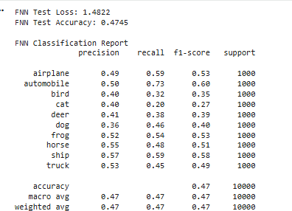

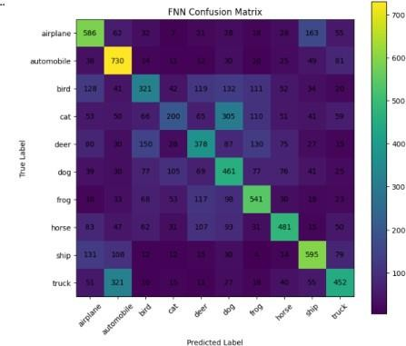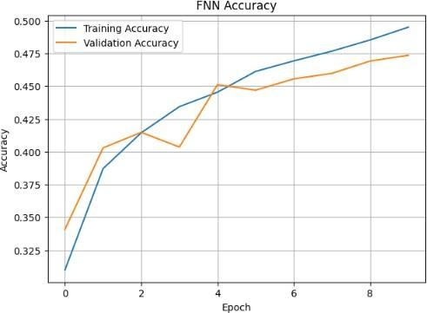
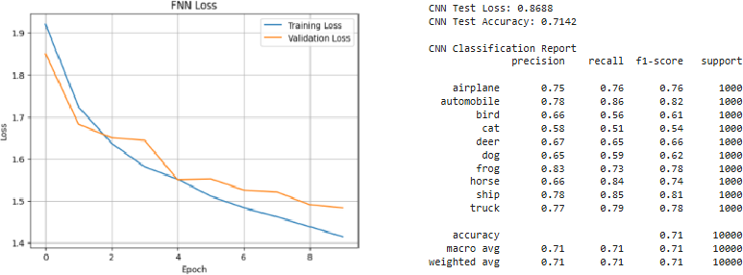
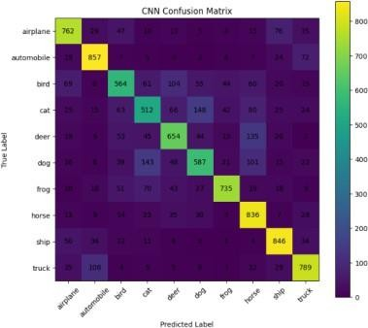
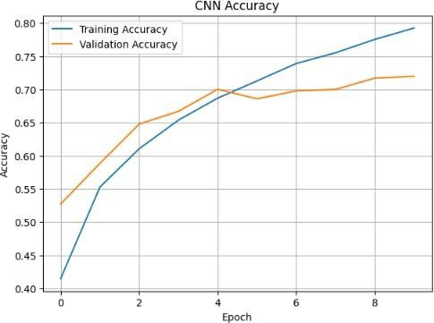
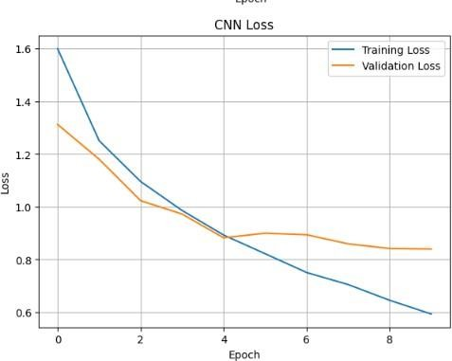
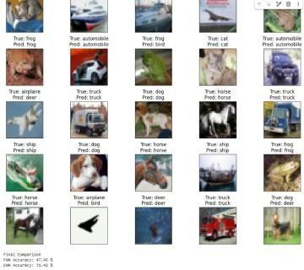

RESULT
Thus, the Feedforward Neural Network (FNN) and Convolutional Neural Network (CNN) were successfully implemented using the Fashion-MNIST and MNIST datasets. The FNN classified flattened Fashion-MNIST images using fully connected layers, while the CNN classified MNIST images using convolution and pooling layers. The CNN effectively learned spatial features from images and provided good classification performance.

